20MCA136 – OBJECT ORIENTED PROGRAMMING LAB Dept. of Computer Applications

|  |
| --- |
| **Name: SREELEKSHMI ANILKUMAR**  **Roll No:42**  **Batch:RMCA S2**  **Date:22-04-2022** |

**OBJECT ORIENTED PROGRAMMING LAB**

**Experiment No.: CO2-1**

# Aim

**Program to Sort strings Procedure**

import java.util.Arrays; public class StringSort

{ public static void main(String args[])

{

String [] names={"Sree","Libiya","Sruthy"};

System.out.println("array names:"+Arrays.toString(names));

Arrays.sort(names);

System.out.println("sorted array names:"+Arrays.toString(names));

}

}

# Output Screenshot

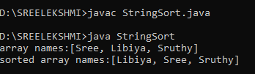

Amal Jyothi College of Engineering, Kanjirappally